**Project Report:**

**Development of the ‘Dunkin Divers’ website**

# Abstract

This paper describes the development of a hobby web site ‘Dunkin Divers’, devoted to the sport of scuba diving. It ties to explain the process in its entirety, following the natural order of the cycle. It starts at the pre-project stage and tries to describe all of the relevant steps in a chronological order. The initial design description is followed by a more detailed description of the methodologies used to implement the finished working web site. While not exhaustive in its description, it will hopefully give the reader a good insight into the work involved in such an undertaking.

Contents

Abstract 1

Background 3

Project selection 3

Website Design and Wire-framing 3

Implementation 6

Methodologies 6

Page Layout 6

JQuery Themeroller 6

Navigation 7

Google Map Page 8

JQuery UI 9

Font Plugin 10

Ajax / JSON 10

Gallery 12

Screenshots 12

Conclusion 14

# Background

This project has been undertaken in part fulfilment of the requirements for a BSc. In Computing at the Institute of Technology, Blanchardstown in Dublin, Ireland. The requirement is to produce an interactive website application from an area of interest or hobby. Also the project can be a real world application or an improvement on an existing website. The following paper endeavours to describe the project as it developed from inception to completion, leading to a working web application and this descriptive document.

# Project selection

The task of selecting a project was accomplished by enquiring of friends and acquaintances if they needed a website built and adding these to a list of hobbies and interests much depleted by previous college projects. From this list the three most likely candidates were selected. A friends existing bookbinding website which needed some improvement, a relatives requirement for a new reflexology site, and a hobby website for a scuba diving club. These were subject to a brain storming of ideas on how they could look along with any pros and cons associated with them. The scuba website emerged as the strongest candidate.

While the optimal choice would have been a real world application, due to the tight time constraints involved, it was felt that these two choices would be best served by being constructed without such a close deadline. Further it was felt that the scuba dive site could easily incorporate some nice underwater pictures. Also the fact of having some prior knowledge of the sport would help to speed up the background research.

# Website Design and Wire-framing

**Look and Feel**: The website at this stage is still a mere idea or concept. As the theme of a scuba diving site is known a decision is made to give the site a marine or a watery theme. The internet was visited on a number of times to gather images and textures which would work well together. Some necessary icons are also gathered at this stage

**Wire-framing**: The page layout was sketched out roughly using pen and paper in an effort to give a pleasing form to the site. After a number of iterations, a design layout is chosen and sketched up in a neater manner than the initial rough work. At this stage some consideration is also given to the interactive elements and functionality of the site, such as the bubble themed navigation bar.

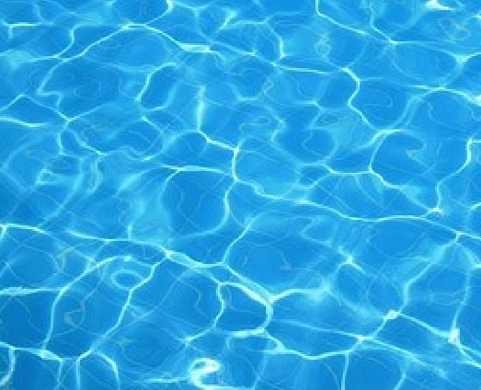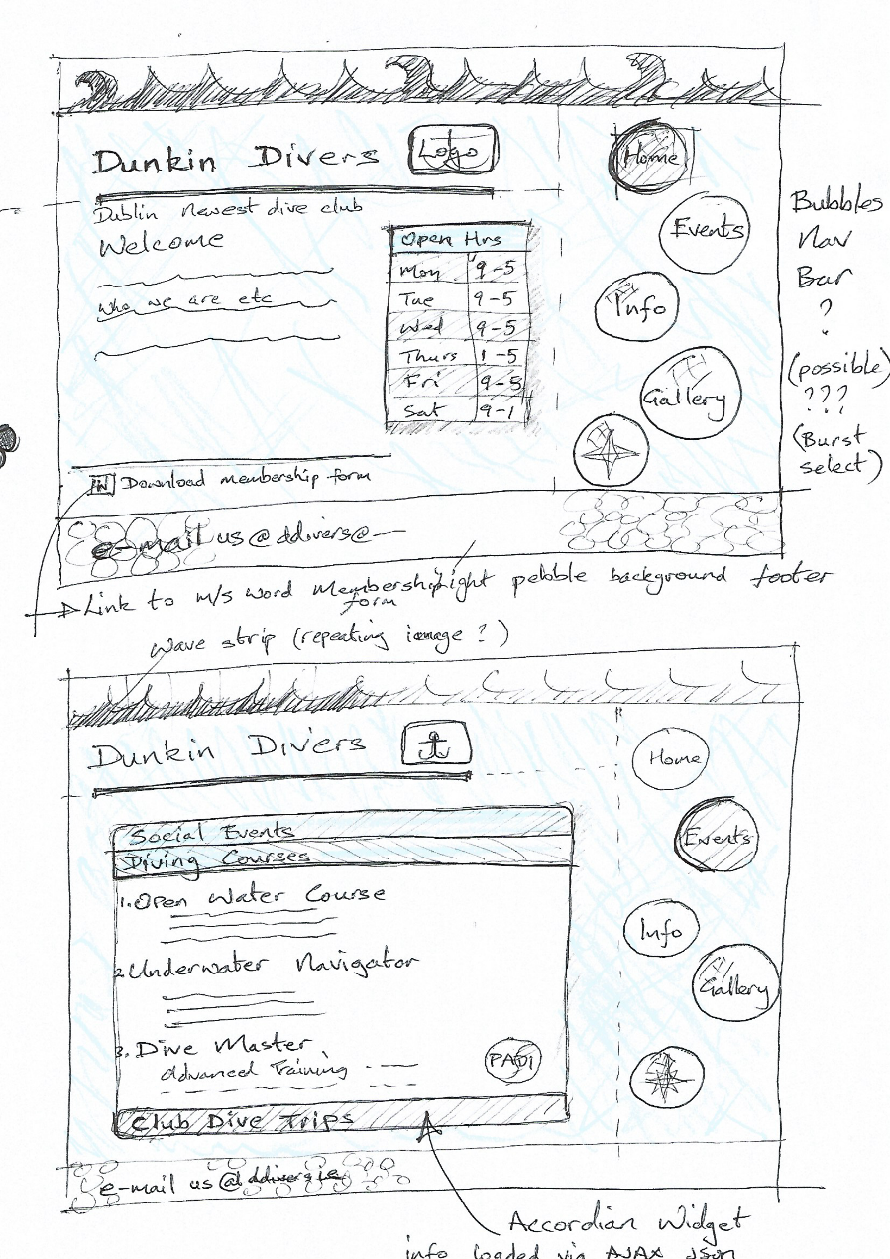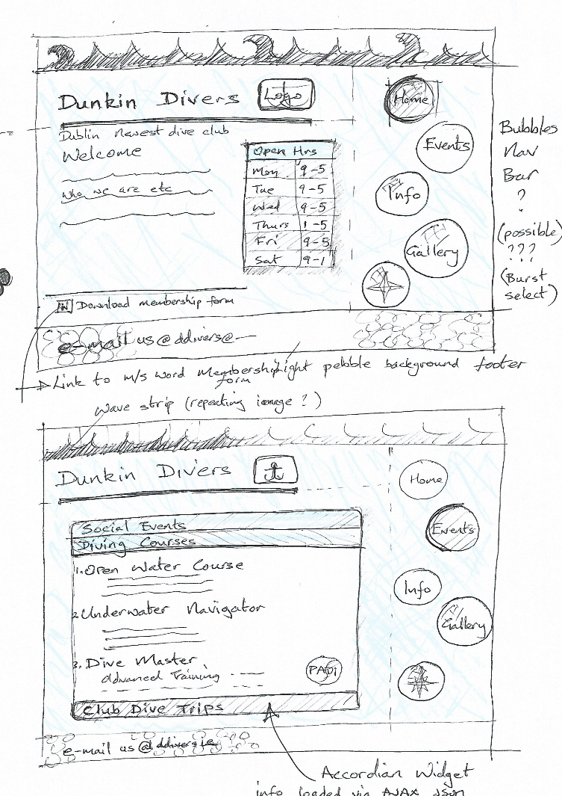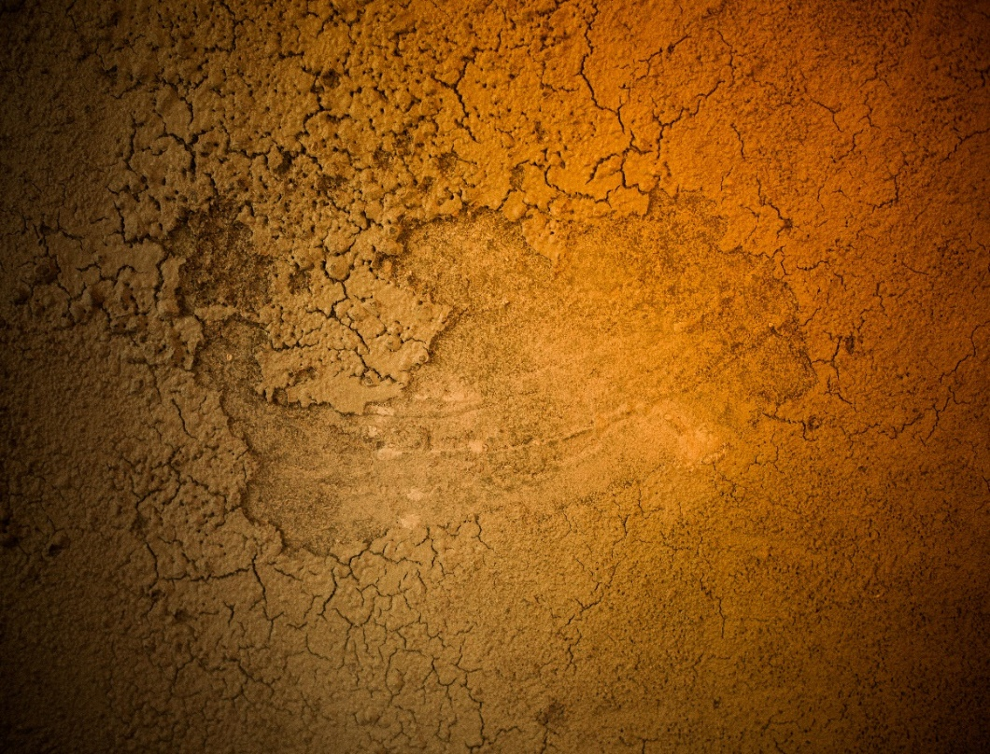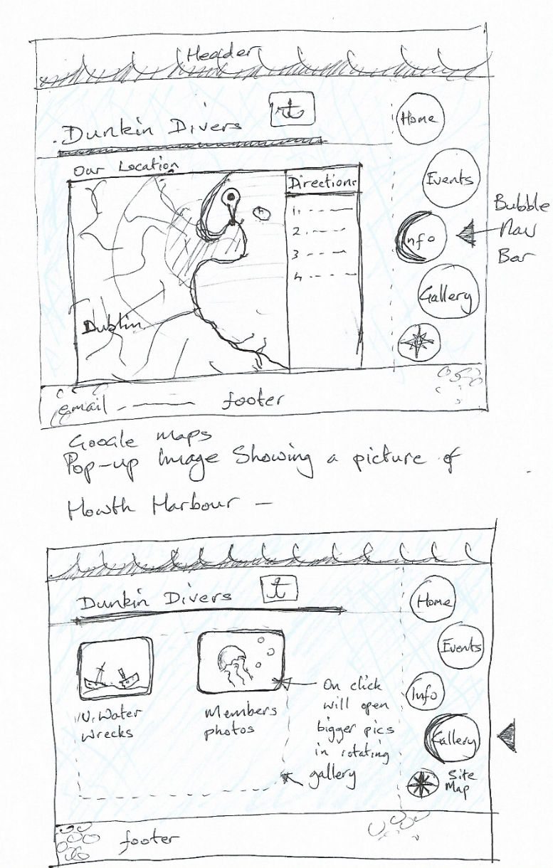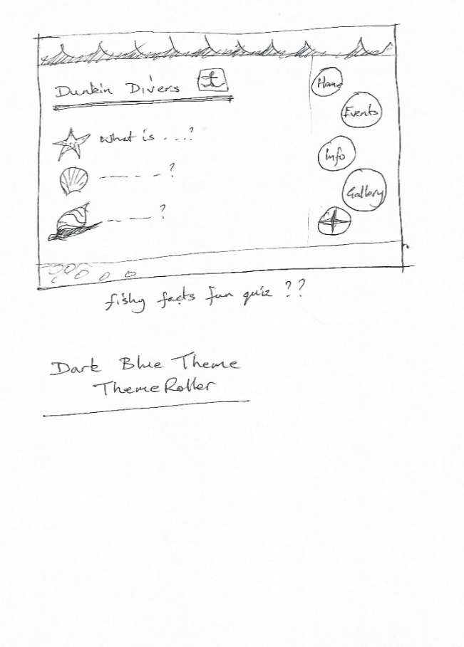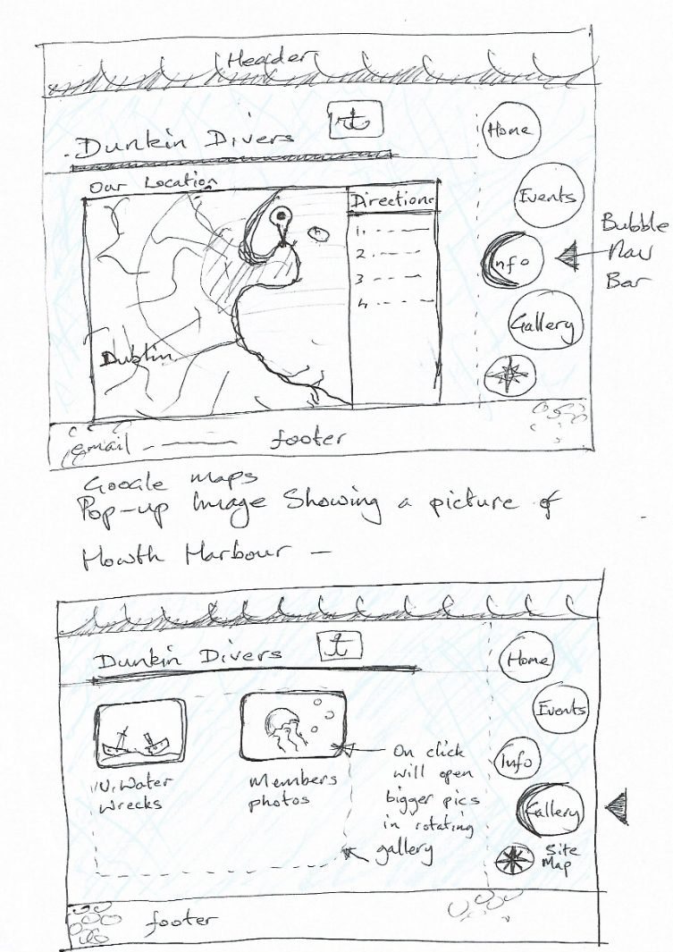

# Implementation

The website was built using HTML, CSS, JavaScript and the JQuery library as its main components. To start the build a Project directory was created with appropriate sub directories for different file types and images. A later stages in the project two additional libraries were added: the jQuery UI (user interface) plugin and the ‘FontAwsome’ icon plugin.

The project presented many challenges, which included the incorporation of some technologies new to the author, such as the jQuery ‘ThemeRoller’ and UI (user interface’) library. These provide a common colour scheme and some useful widgets to add interest to the site. Some of the major areas of implementation are described in the following section.

# Methodologies

## Page Layout

This did not present any great problems. A page framework was constructed using HTML and CSS to form a full width header and footer which would be common to all the pages on the site. Next a vertical navigation bar was constructed using an ordered list of page hyperlinks and floated to the right hand side of the page. A background image is used as a fixed backdrop for the site. This will be reviewed as the site develops.

## JQuery Themeroller

Some research and reading on the jQuery website was needed to understand how this JavaScript plug-in is used in web development. It turns out that it is part of the jQuery UI framework. On the jQuery site there are a number of pre-defined themes which the user can select, and customise further if they wish. When a selection is made, the user is then presented with a screen showing the different components of the UI which can be selected for the package, this must include the core components of the UI plug-in.

A theme was chosen based on the ‘Dot Luv’, theme modified slightly and downloaded with all the UI elements just in case any were deeded later. The package included a JavaScript file, three CSS files and a folder of images for the CSS directory. These were placed into the project directory.



## Navigation

The navigation bar is presented as a vertical list of hyperlinks. This was further styled with a striped blue background taken from the ThemeRoller files to tie the element into the common ‘look and feel’ of the site.

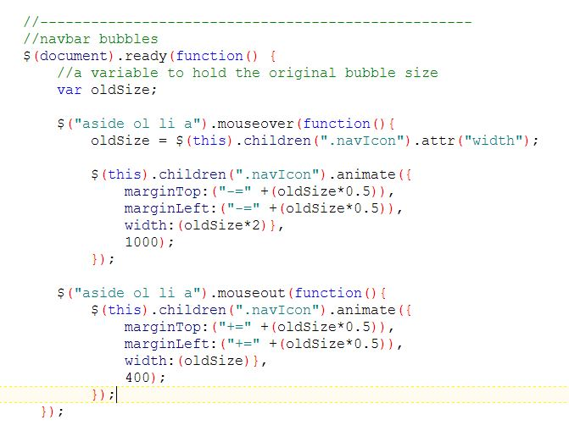A bubble image was added to the links using a ‘.png’ file, as this allows a transparent background to the image. Each instance of the image was given a different size and vertical alignment to give the effect of a stream of rising bubbles. Next the jQuery UI library was used to animate the bubbles when a user places the mouse cursor over the link. This was achieved by writing a JavaScript to expand the bubbles on a mouse-over event and return the image to its original size on a mouse-out event. A number of versions were tried before the completed code was arrived at:

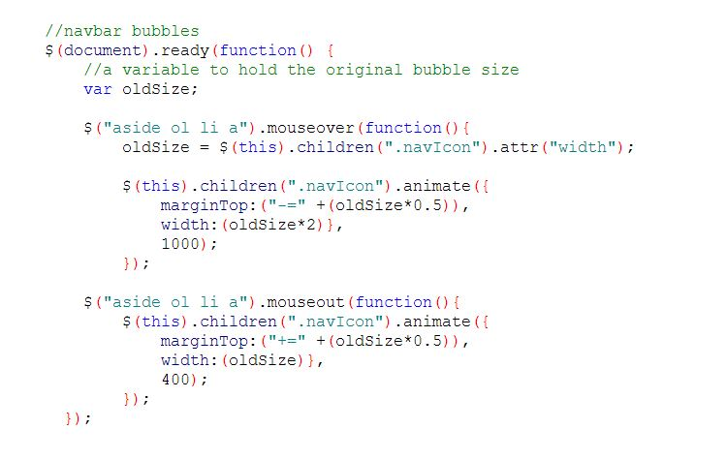

## Google Map Page

Initially a couple of jQuery map plug-ins were downloaded and examined as to how they could be used to build a map easily into the web app. However these proved to have documentation which was difficult to follow for the author. However the google site proved much more accessible, even though it hosts a very large document set. After some initial reading an account was setting up for a ‘hash-key’ which allows a website to host a google map and be allowed more map look-up queries per day. Following this was more research of which of the many of the available API’s to use. The JavaScript API was used. The execution is achieved by:

1. 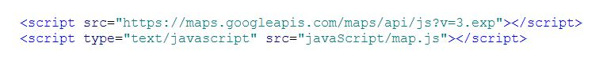Placing a call to the map library header, along with a script call to the Javascript file which sets out the map variables:
2. 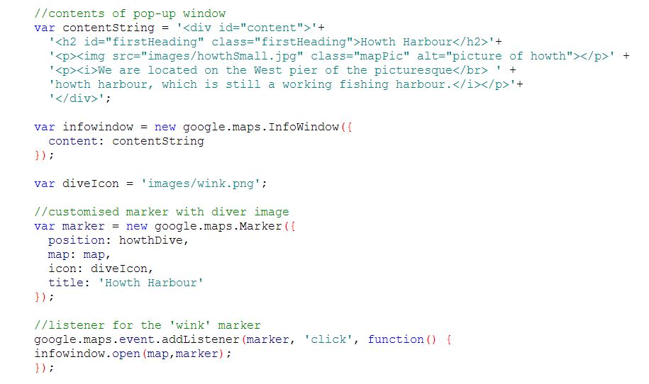By using the map API to manipulate the map for the desired display. In our case we had a requirement to provide directions to the dive club, as well as a marker to give a short description and an image when clicked. The following is a section of the ‘map.js’ file showing the code for the customised marker:

## JQuery UI

The use of this library is quite straightforward. It involves placing the HTML content in a set pattern of ‘divs’ which are identified with tags pre-determined by the UI API. A simple JavaScript method then does all the work of transforming the HTML block into the UI widget. The ‘accordion’ and ‘tabs’ widgets were both used on the site.

The accordion was implemented with a simple JavaScript call but gave a little trouble at first insofar as it expanded vertically as more content was added even if it was open on a division with only a little content:

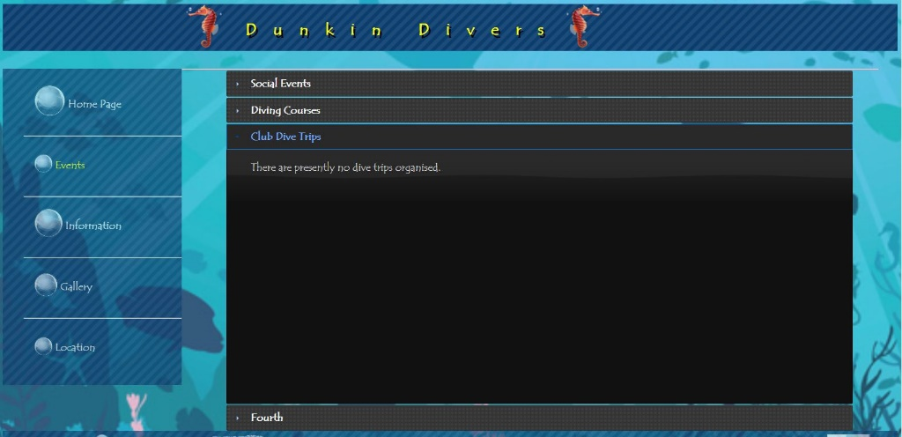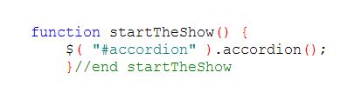

This was fixed by adding two more arguments to the ‘accordion ()’ method: call heightStyle and collapsible which fixed the growing height problem and also allows all of the content bars to close allowing our nice background image to be seen.

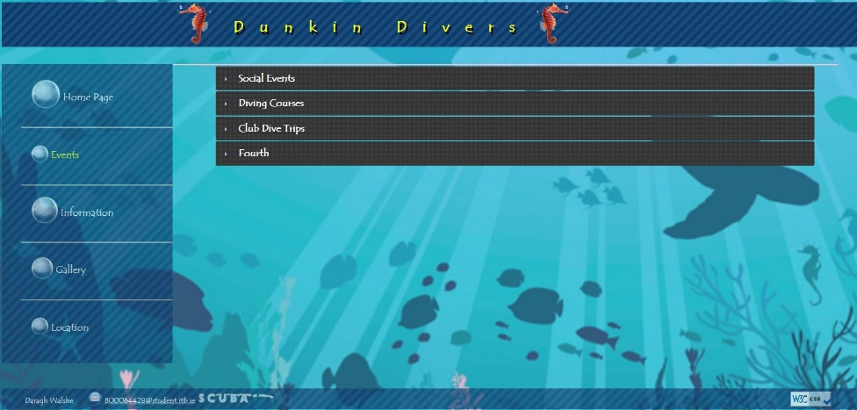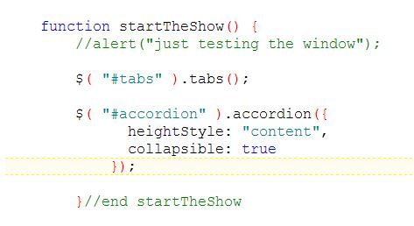

## Font Plugin

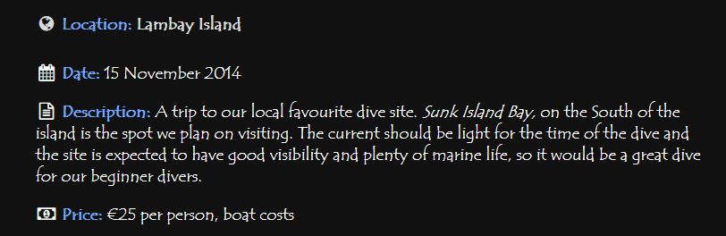At a late stage in the project, some difficulty was encountered while trying to style the bullet point icons on an unordered list. This can be a notoriously fiddly operation with various different styling elements upsetting the desired result. While searching for information on the styling problem we found a nice solution in the form of an open-source plug-in ‘Font Awsome’. This is similar to jQuery in that it uses CSS classes which are called from the HTML tags. Where it differs is the fact that it uses icons which have been converted to font files, so are quicker to load than vector graphics. The plug-in comes with over 700 consistently styled icons which was a nice bonus. Used by placing a pre-defined class inside a ‘i’ or a ’span’ tag. There are a number of different classes for different situations. The following example uses a class with the ‘xxx-fw’ extension which stands for fixes width. This is useful for vertically aligned lists where the icons may be different sizes:

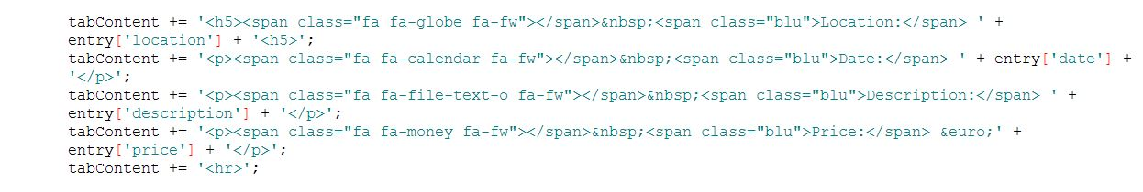

## Ajax / JSON

This was implemented in two different ways in the construction of the site.

The first method was implemented in conjunction with the jQuery UI frameworks ‘beforeLoad’ method, belonging to the ‘tab’ widget, which allows a message to be displayed in case of a problem loading the desired content. It is a straight forward process of setting up a division containing a list of links to the content which should be loaded when its tab is opened.

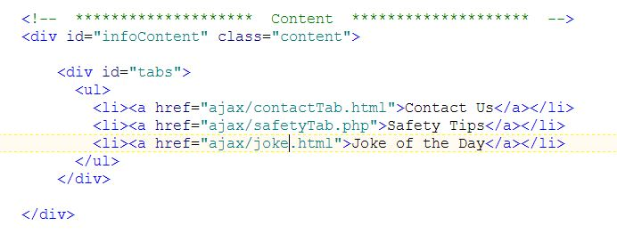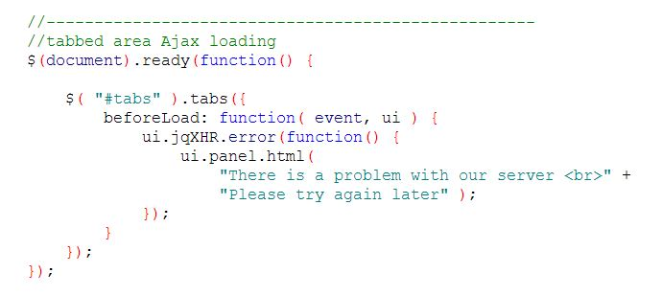

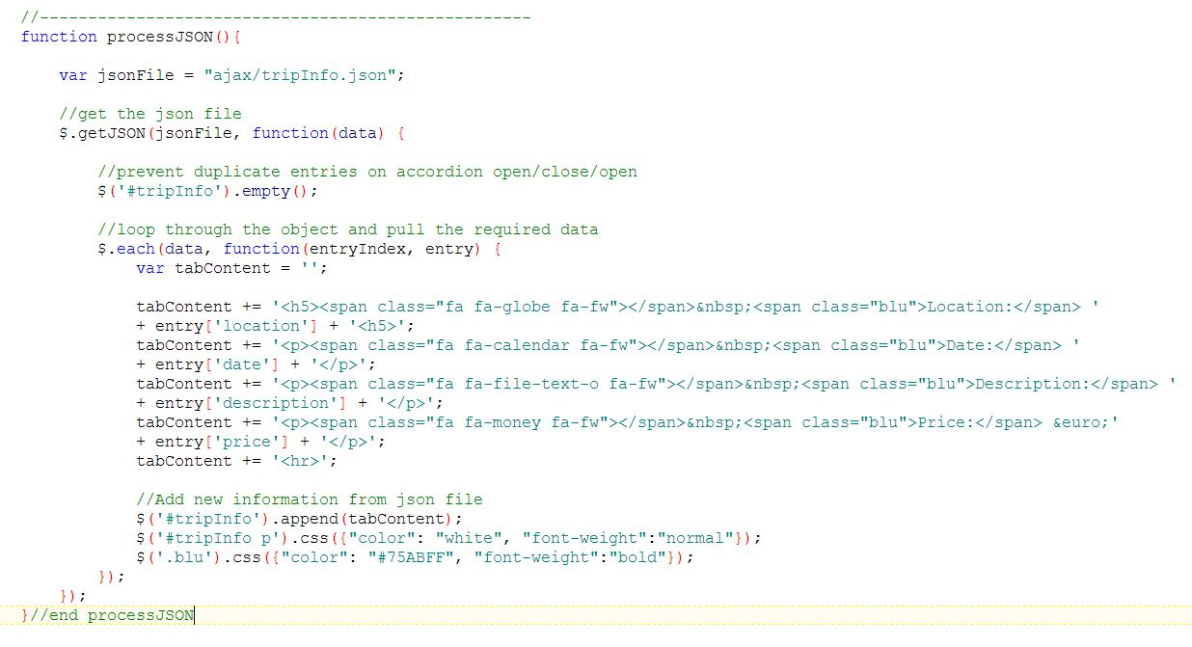The second method was to use the jQuery ‘$.getJSON’ method to query the server for the relevant file. This is implemented mainly through JavaScript. The json file is returned as a data object. The key-value format of the json file is used to extract the relevant data by means of a loop to build a new HTML fragment which is then placed into the web page.

## Gallery

This page was constructed by using a generic image rotator, and placing it into a re-sizeable division of the page. The sidebar contains three images in a selectable division, one or more of which can be selected to play its corresponding slideshow. The slideshow is built by inserting the html fragment into the page when the image on the left is selected. This is accomplished with JavaScript functions. The code is not shown here as it is too long to sit comfortably in this report. At the time of writing there is still a minor bug in the slideshow code, in that it will not resume playing after being paused, but it should not prove too difficult to track down.

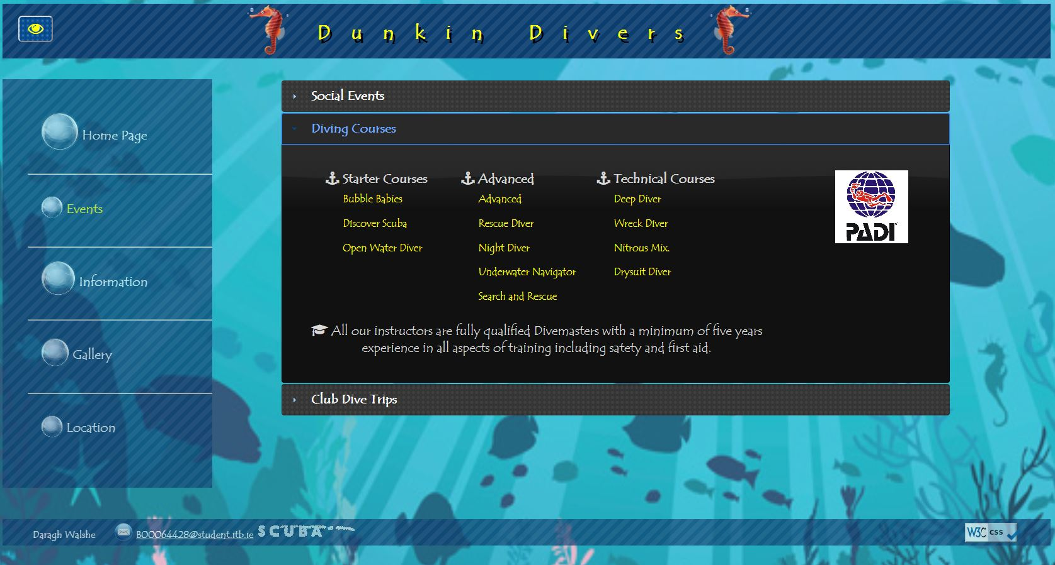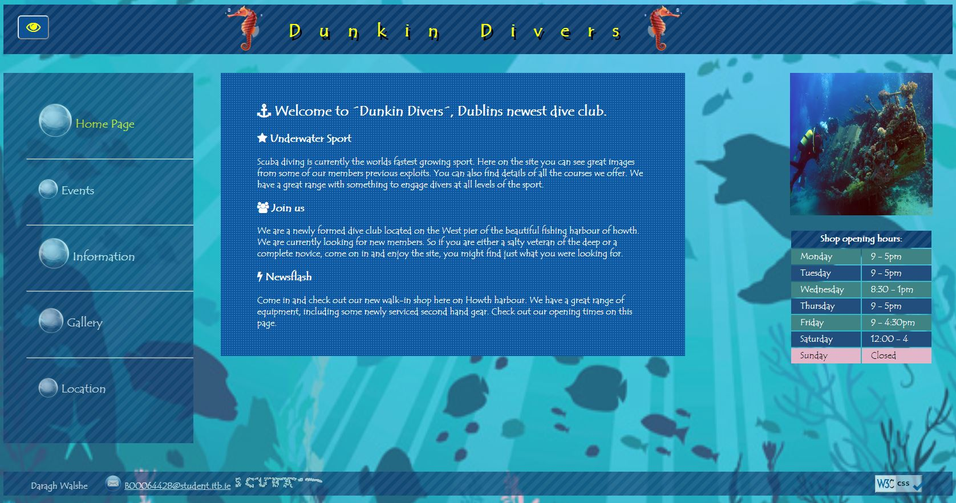

# Screenshots

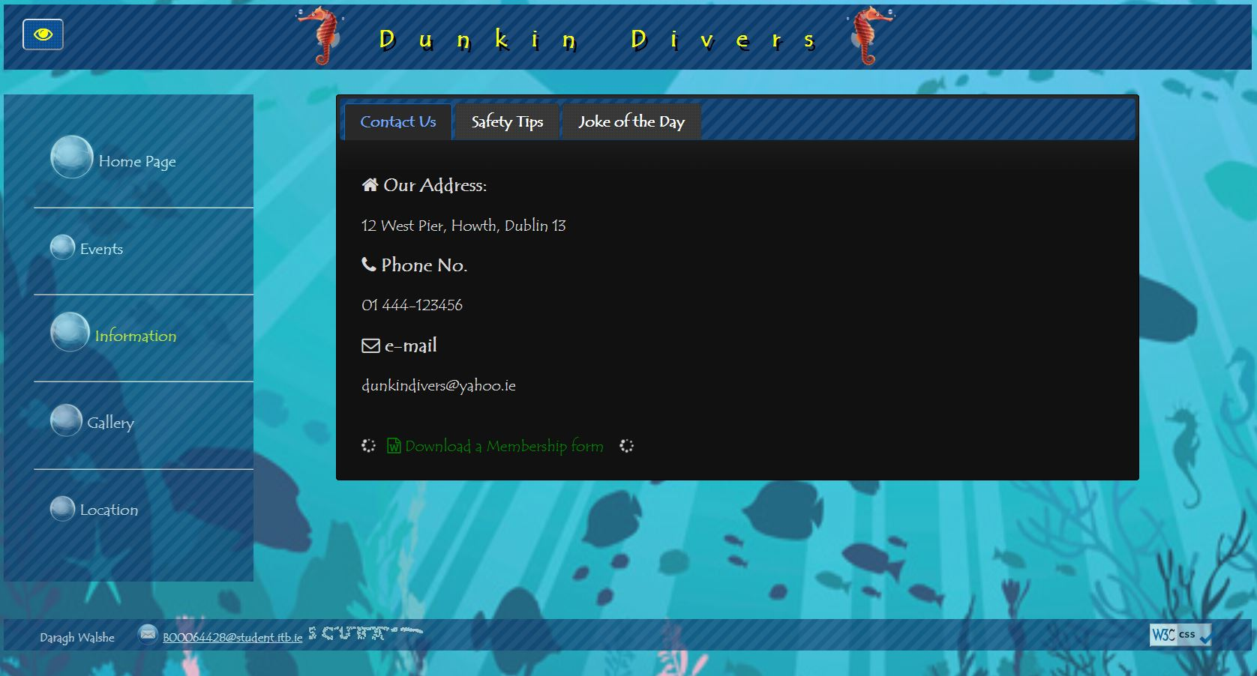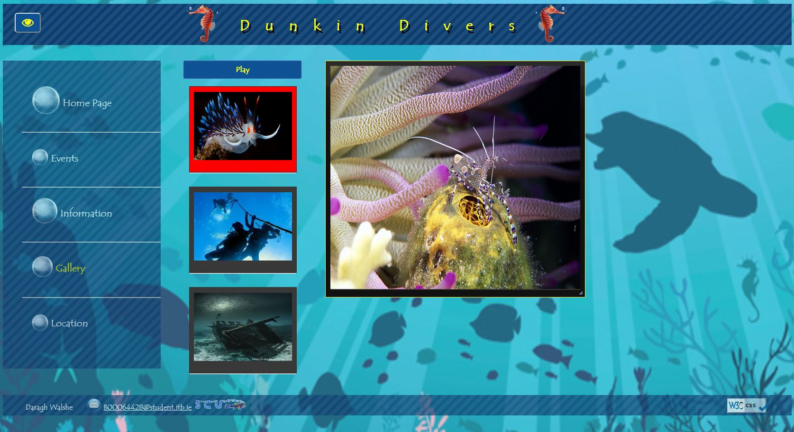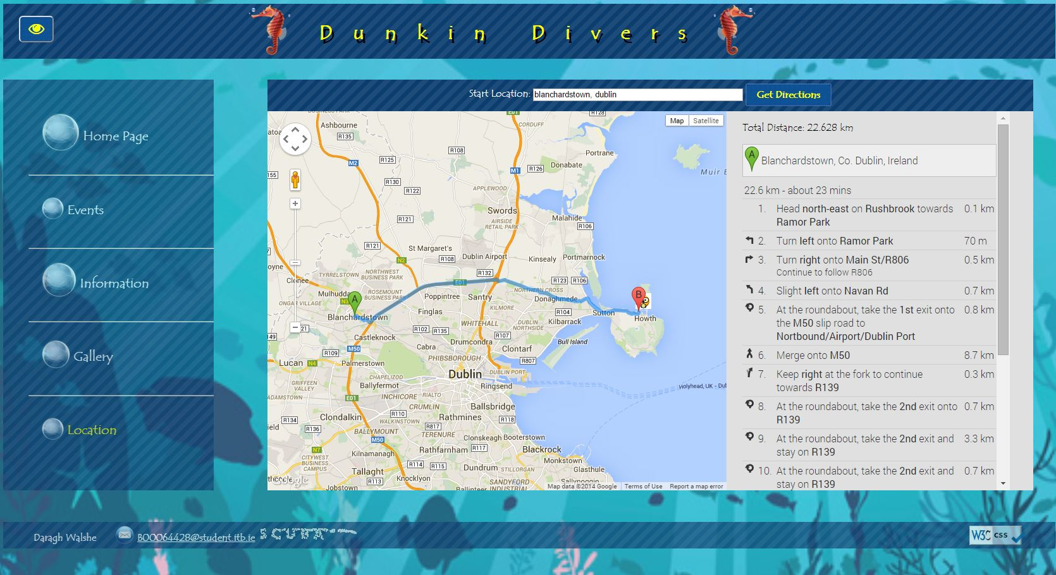

# Conclusion

The development of the system posed a robust challenge for a student with practically no knowledge in the use of jQuery and its related libraries. The documentation for the API was found at times to be hard to understand, but perhaps this could be attributed to a lack of experience. The biggest challenge of the entire project was, in the opinion of the author, the very tight time frame which was allowed for the work. Overall though the end result was a very pleasing outcome, and worth all the effort.